

**School of Engineering and Applied Science,**

**Ahmedabad University**

**CSE300 Software Engineering**

**Weekly Report**

**Guided By: Prof Khushru Doctor**

**TA Muskan Matwani**

**TA Anupama Nair**

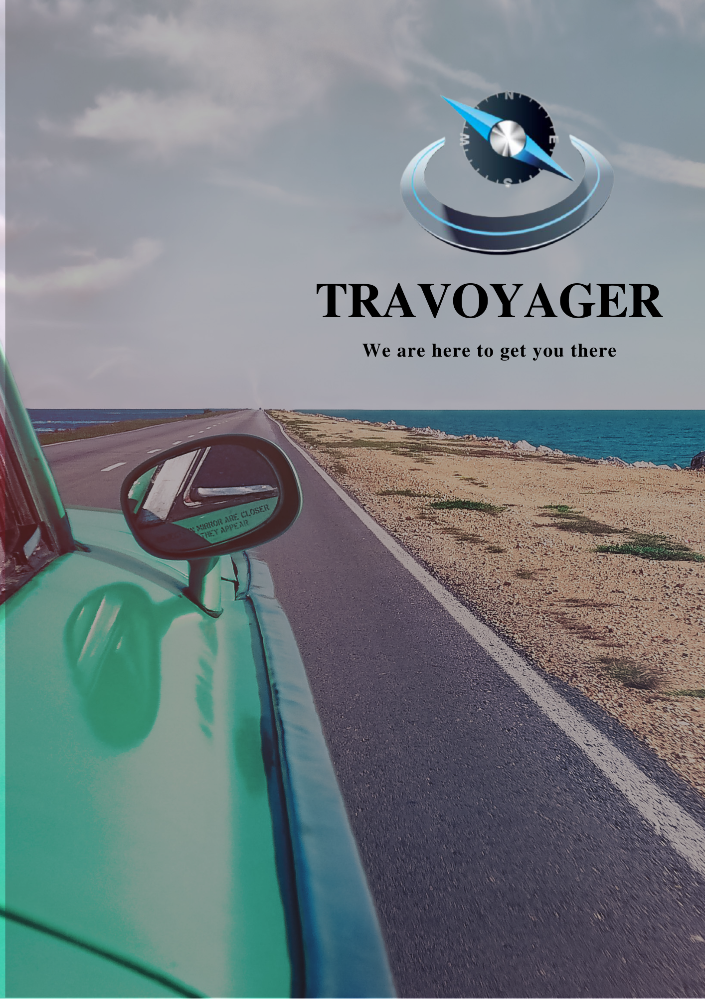

**WEEKLY MEETING REPORT - 9**

**Agenda** - Sprint 4 Discussion

**Date and Time**

**________________________________________________________________________________________________________________________________________________________________________________________________________________________________________________________________________________________________________________________________________________________________________________________________________________________________**

April 4 , 2021 11:00 A.M.-12:00P.M.

**Location**

**________________________________________________________________________________________________________________________________________________________________________________________________________________________________________________________________________________________________________________________________________________________________________________________________________________________________**

Google Meet

**Schedule**

**________________________________________________________________________________________________________________________________________________________________________________________________________________________________________________________________________________________________________________________________________________________________________________________________________________________________**

|  |  |
| --- | --- |
| **Time** | **Description** |
| 11:00-11:05 A.M. | Attendance |
| 11:05-11:30 A.M. | Progress Sharing |
| 11:30-11:45 A.M. | Backlog Discussion |
| 11:45-11:55 A.M. | Sprint 5 |
| 11:55 A.M. - 12:00 P.M. | Summary |
| 12:00 P.M. | Meeting Adjourned |

**Details**

**________________________________________________________________________________________________________________________________________________________________________________________________________________________________________________________________________________________________________________________________________________________________________________________________________________________________**

1. Progress

1. Frontend Team
   1. Home Screen Design
   2. User inputs screen Design
2. Backend Team
   1. Queries related to generating the itinerary and displaying it on screen as per the inputs

2.Backlog

1. Frontend Team
   1. Itinerary screen design
2. Backend Team
   1. NULL

**Conclusion**

**________________________________________________________________________________________________________________________________________________________________________________________________________________________________________________________________________________________________________________________________________________________________________________________________________________________________**

As per the sprints decided, frontend and backend teams were assigned the tasks accordingly for Sprint 5. Beginning of Sprint 5.

**Next Meeting Details**

**________________________________________________________________________________________________________________________________________________________________________________________________________________________________________________________________________________________________________________________________________________________________________________________________________________________________**

April 11, 2021 11:00A.M. -12:00P.M.

**Next Agenda**

**________________________________________________________________________________________________________________________________________________________________________________________________________________________________________________________________________________________________________________________________________________________________________________________________________________________________**

Meeting 10 - Sprint 5 Discussion